Event Registration:
8 - 9:45 am on April 13, 2019
Place: Richfield VFW - Lake St, Richfield Springs, NY 1/8 mile South of Route 20
RACE START TIMES
9:30 am - Kids “Little Loop” 9:45 am - 10K, and 10 am- 5K and 2 mile walk
REGISTRATION FEES
Kids “Little Loop” Registration Fee: FREE Rewards for all Little Loopers
Run or Walk Registration Fees for Adults and Students:
Pre- Registration (postmarked on or before 4/13/19): $25 Day of Race: $30
AWARDS
• Tech-shirts to the first 75 entrants (5K/10K & 2mi)
• Trophies - overall male/female (5K/10K)
• 1st - 3rd place awards for age groups up to 80-89 (5K/10K)
•
Register online at www.runsignup.com or mail check and application to Bill Kosina, 1434 County Highway 25, Richfield Springs, NY 13439
RSCC RUN/WALK APPLICATION
Name:__________________________
Age (on 4/13/19):______
Gender (circle one): M F
Course Type (circle one): 10K Run
5K Run 2 mile Walk “Little Loop”
Address:________________________Email:___________________________
Amount: __________
T-Shirt (circle one): Small Medium Large XL
WAIVER In consideration of acceptance of this application, I, the undersigned, intending to be legally bound, hereby, for myself, my heirs, executors, administrators, and assigns waive any and all rights and claims for damages I may have against the Richfield Springs Community Center, their representatives, and successors for any and all injuries suffered by me at the races to be held in Richfield Springs, on April 13, 2019. I verify that I am physically fit and have trained sufficiently for the competition.
Signature_______________________________________________
Date ___________________________
Guardian (under 18)____________________________________
Date __________________________
Please make checks payable to: “RSCC” Mail check and applications to: Bill Kosina

ABOUT THE COURSE
The open 10K is a hilly course with its challenge at the start. The 5K is an “out and back” on rolling hills. The 2 mile Walk starts on Lake Street and proceeds “out and back” Cemetery and Butternuts. The kids “little loop” is approx. 1⁄2 mi. total (out and back), starting and ending at the start/finish line with ribbons given.
THANK YOU TO OUR SPONSORS! We are proud to be part of the
Route 20 Road Challenge!
Visit www.nyroute20.com for more information.
Questions? Contact Bill Kosina 315-749-3286 jabkos@verizon.net
Home of The Zone Youth Program

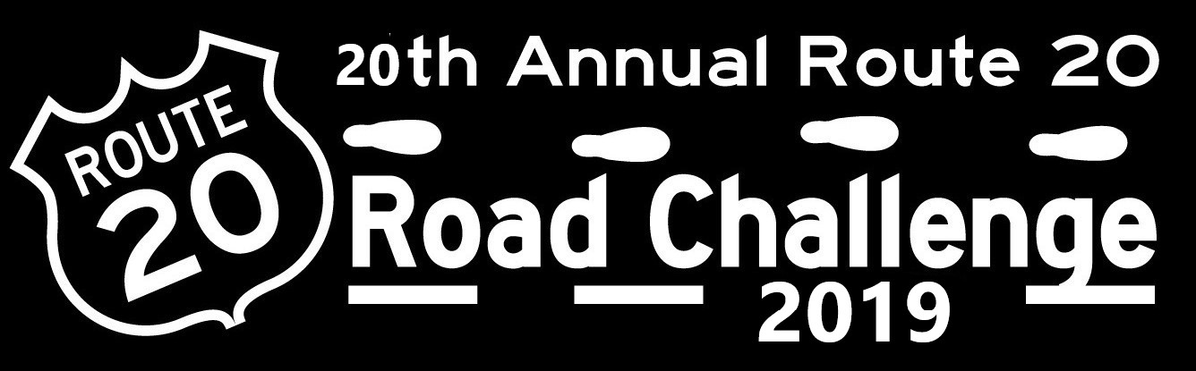

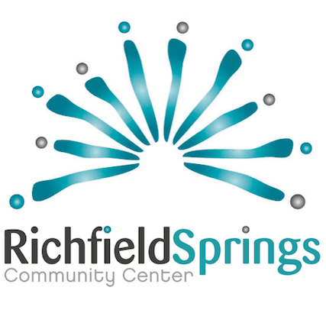
April 13, 2019 5K, 10K 2 Mile Walk and Kids “Little Loop”
ZONE RUN & WALK
New: Free draft beer/ soda or bottled water for every registered runner/walker